DANANG VOCATIONAL TRAINING COLLEGE
FACULTY OF INFORMATION TECHNOLOGY
___________________________________________________

GRADUATION PROJECT

PROJECT NAME
VEHICLE REPAIR 4.0



Tuesday team Student : Trần Văn Tài
Đặng Phương Nam
Đinh Thị Thanh
Nguyễn Thị Ti
Ngô Thị Trà Giang
Class : 17PNV1A & 17PNV1B
Supervisor : MR. Lê Tiến Đình

Da Nang, 18 September 2020

ACKNOWLEDGEMENT

The success and final outcome of this project required a lot of guidance and assistance from many people and my team is extremely privileged to have got this all along with the completion of my project. All that the team has done is only due to such supervision and assistance and we would not forget to thank them.

We respect and thank Mr Lê Tiến Đình, for providing us with an opportunity to bring an idea into reality in school and giving us all support and guidance which made us complete the project duly. We are extremely thankful to him for providing such a nice support and guidance, although he had a busy schedule in the school.

We owe my deep gratitude to our project guide Mr Phan Văn Linh, who took keen interest on our project work and guided us all along, till the completion of our project work by providing all the necessary information for developing a good system.

We are thankful to and fortunate enough to get constant encouragement, support and guidance from all Teaching staff of Passere Numeriques and Da Nang Vocational Training College which helped us in successfully completing our project work.

STATUTORY DECLARATION

We herewith formally declare that we have written the submitted thesis independently. We did not use any outside support except for the quoted literature and other sources mentioned in the paper. We clearly marked and separately listed all of the literature and all of the other sources which we employed when producing this academic work, either literally or in content. We are aware that the violation of this regulation will lead to failure of the thesis.

Students:

Trần Văn Tài
Đặng Phương Nam
Đinh Thị Thanh
Nguyễn Thị Ti
Ngô Thị Trà Giang

TABLE OF CONTENTS

Contents
ACKNOWLEDGEMENT 2
STATUTORY DECLARATION 3
TABLE OF CONTENTS 4
TABLES OF IMAGES 6
INTRODUCTION 7
1. Project introduction 7
1.1. Overview Idea 7
1.2. Approach 8
1.2.1. Online survey 8
1.3. 1 Traditional survey 9
1.4. Business Model Canvas 10
2. Main functions of project 10
2.1. Summary the main features 10
2.2. Project scope 10
CHAPTER 1. THEORY OVERVIEW 12
1. React (Framework) 12
1.1. What is ReactJs? 12
2. React Native (Framework) 12
2.1. Motivation behind building an Android app with React Native 12
2.2. Setup React Native 13
2.3. Apply React Native 14
3. React JS and Redux 14
3.1. React JS 14
3.2. Redux 15
4. ASP.NET Core 16
4.1. What is ASP.NET Core? 16
4.2. Why we choose ASP.NET Core? 17
5. Swagger UI 17
5.1. What is Swagger UI? 17
5.2. Why choose Swagger UI for API Testing? 17
6. Firebase 18
6.1. What is Firebase? 18
6.2. Firebase Cloud Messaging (FCM) 19
6.3. Firebase Phone Authentication 20
7. Figma (Design) 21
7.1. What is Figma? 21
7.2. How to use Figma? 21
7.3. Download App 23
7.4. The power of a Figma 23
8. GIT (Source code management) 23
8.1. What is Git? 23
8.2. Rule use Git into project 24
CHAPTER 2. PROJECT INTRODUCTION AND SOLUTION 26
1. Project Details 26
1.1. Data Requirements 26
1.1.1 Use Case Product 26
1.1.2 Database 26
1.2. Project Functions 27
1.2..2. App for Fixer 30
1.2..3. Website for Admin 30
2. Solution 30
CHAPTER 3. IMPLEMENTING AND TESTING 32
CONCLUSION 33
REFERENCE 35
SUPERVISOR COMMENTS 36

TABLES OF IMAGES
Image 1: User has vehicle 7
Image 3: Summary online survey 8
Image 4: Survey with the owner station 9
Image 5: BMC image 10
Image 5: Logo react 12
Image 6: Structure of Redux 16
Image 7: ASP.NET 16
Image 8: Swagger UI 17
Image 9: Comapare firebase with another platform 18
Image 10: Compare firebase with another platform 19
Image 11: Push notification sent by FCM 19
Image 12: SMS sent by Firebase Phone Authentication 20
Image 13: Logo Figma 21
Image 14: Figma home page 22
Image 15 : Starting a project by Figma 23
Image 16 : Git logo 24
Image 17 : Usecase Product 26
Image 18 : Database 27
Image 19 : Registration in User App 28
Image 20 : The code send user after registration 28
Image 21 : Login in User App 29

INTRODUCTION

Project introduction

Overview Idea
Create an application that helps people find the nearest vehicle repair station that it is operating. Our objectives are the people to have and use vehicles and owners of vehicle repair stations. The benefits that this application will bring are:

Image 1: User has vehicle
For customers, they can save time when they search for a vehicle repair station and they will get a reasonable price when they repair vehicles with information about the service available on the app.
Image 2: The owner of vehicle repair station
For owners of vehicle repair stations: they will be promoting the store, helping them increase profits and increase customers.

Approach

Online survey
An online survey created the listing questionnaire that the target student or employee (200 people) can complete over the Internet by email. The team uses online surveys to gain a deeper understanding of their customers’ tastes and opinions. The online surveys can be used in basic ways: To provide more data on customers about vehicle use, including everything from basic demographic information (age, information) to behavior data. To create a survey about a specific product, service, or brand in order to find out how consumers are reacting to it.
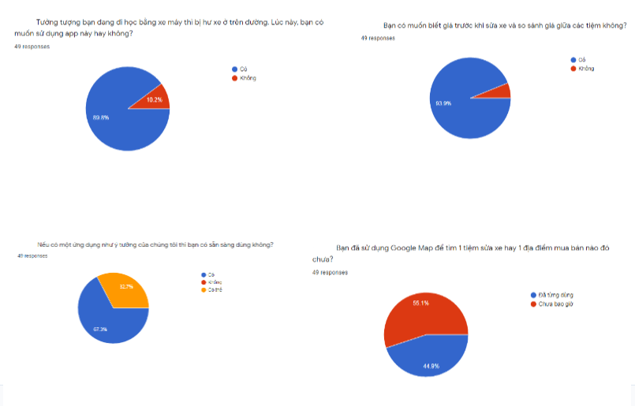
Image 3: Summary online survey

1 Traditional survey
These surveys we go where the vehicle repair shop in da nang to research information (number of customers, revenue) especial we introduce about the app " Finding vehicle repair stations"
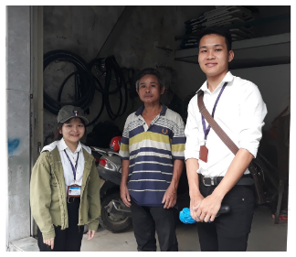
Image 4: Survey with the owner station
With the result:
- 75% of Repair stations agree to use the app
- 25% of Repair stations refuse to answer because they are busy

Business Model Canvas
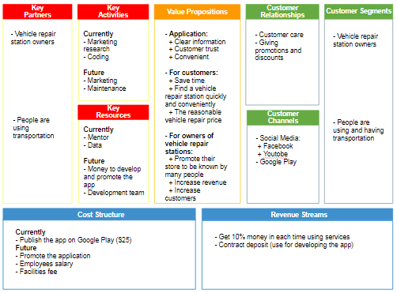
Image 5: BMC image

Main functions of project

Summary the main features
      - Created the app for the user (Search for a vehicle repair station is operating, book the store, cancel and rating)
      - Created the app for fixer (Add the product of the store into the app)
      - Website for admin Management the product service order, data statistic)

Project scope
- Schedule to complete
  - The application “Finding vehicle repair stations “will start once the main work is finished. The product will be released within two months and present before talking to an intern. But due to COVID-19, we have four months for both finishes the project and intern at the company.
- Project object
  - The team tries the best to use the SMART model for setting Specific, Measurable, Attainable, Relevant, and Timely goals. It helps our app and websites state-of-the-art, user-friendly websites and applications are truly a passion of us.
- Technical use in the project
In addition to our knowledge base, we actively seek out new technologies and advancements:
  - The application: React Native
  - The website: React JS, CSS, HTML
  - API: Swagger UI
  - Test tool:
  - Task management: Trello
  - Source code management: GitHub
  - Design tool: Figma

CHAPTER 1. THEORY OVERVIEW
To implement this project, we have applied some of the following knowledge and research:
- React (Framework)
  - What is ReactJs?
React is a front-end library developed by Facebook. It is a declarative, efficient, and flexible Javascript library for building user interfaces.
  - How does it work?
It is used for handling the view layer for web and mobile apps. It allows us to create reusable UI components. It is currently one of the most popular JS libraries and it has a large community and documentation behind it as well as a strong foundation.

Image 5: Logo react
- React Native (Framework)
  - Motivation behind building an Android app with React Native
There were two main reasons that make us decide to build this app with ReactNative.
The first one is we have experience with web development. We thought that it would be very interesting and fun to be able to use a framework based on web development protocols in the making of an iOS app.
Our second reasons is ReactNative is “Learn once, write anywhere”. This means that we only have to learn how to work with the ReactNative framework once to be able to build mobile apps on many platforms, including iOS, Android, and many others. This particular characteristic of ReactNative is very appealing. ReactNative provides a Javascript library to interact with native components to each platform. I had access to all the native iOS components (camera, ListView, GridView, ImageView…) and was able to interact with them through Javascript.
  - Setup React Native
- Setup Android Studio
  - Android Studio installs the latest Android SDK by default. React Native requires Android 6.0 (Marshmallow) SDK or higher. We decided to use Android 8.0.0
- Install NodeJs & NPM
  - You need to install the NodeJS version latest and NPM before setting up the environment for React Native
  - npm install
  - npm install -y nodejs. install jdk8
- Install JDK
  - If you have already installed Node.js, make sure it has version above 8 and if you have already installed JDK, make it version 8 or newer version.
- Install react-native-elements
  - npm i react-native-elements –save
- Install react-native-vector-icons
  - npm i --save react-native-vector-icons
  - Apply React Native
These are the main concepts we have learnt about React/ReactNative which were implemented in our project:
JSX: Allows us to combine markup and JS logic in a single component.
Virtual DOM: React creates a JS representation of the actual DOM, then applies a diffing algorithm to find which pieces of the DOM need to be changed. React applies the changes without rebuilding the whole DOM. This makes the UI rendering very fast.
States: Allows us to manipulate the UI through a couple of methods
GetInitialState: Allows us to set the initial state of each component.
SetState: Helper method to update the state of a component
Props: Using props, we can send data to child components, it is a powerful way to render dynamic data.
Events: OnClick, OnSubmit, OnChange: these are event handlers that allow us to detect user input (interaction through the UI) and use the event to modify the UI accordingly.
- React JS and Redux
  - React JS
- ReactJS is an open-source JavaScript library for building user interfaces. It is used for handling view layers in single-page applications and mobile application development. It is maintained by Facebook, Instagram, and a community of developers and corporations.
- React strives to provide speed, simplicity, and scalability. Some of its most notable features are JSX, Stateful components, Virtual Document Object Model.
- Choose the React JS building an admin website
  - Development efficiency - Less development time and higher quality
  - React allows you to write modular and clean code, breaking the project into separate components. This also allows for code reuse, which can really boost developer productivity.
  - Easy transition to React Native
  - React Native is a mobile development framework, based on React. Thus, it is easy for React JS developers to switch to React Native and create mobile apps with a native look and feel. Moreover, some parts of our React web app can be reused in a React Native mobile app which improves the development speed.
  - Redux
Redux is a predictable state container for JavaScript applications. State management is one of the most difficult aspects of software development. State mismanagement is the source of the most errors. Redux is a simplified implementation of Facebook’s Flux architecture which is a Model-View-Controller framework. It lessens the complexity by using reducers. Redux reducers are functions without side effects that compute application state.
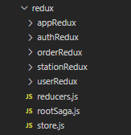
Image 6: Structure of Redux
- ASP.NET Core
  - What is ASP.NET Core?
ASP.NET is a popular web development framework for building web apps on the .NET platform.
ASP.NET Core is the open-source version of ASP.NET, which runs on macOS, Linux, and Windows. ASP.NET Core was first released in 2016 and is a re-design of earlier Windows-only versions of ASP.NET.
With ASP.NET Core, we can build a RESTful API with request methods such as GET, POST, PUT, and DELETE. With this API, we can connect to from mobile apps as well as our admin management page.
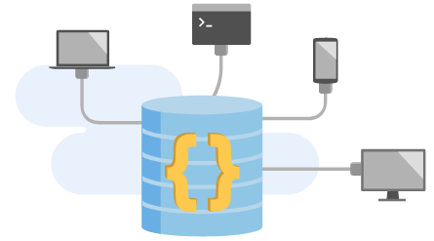
Image 7: ASP.NET

  - Why do we choose ASP.NET Core?
There are 2 reasons that make us decide to use ASP.NET Core to build our Server.
Firstly, ASP.NET Core is open-source. It is a lightweight architecture so it is easy to power HTTP services and can reach a broad range of clients including mobile devices.
Secondly, at that time, we have a team member who has experience and is learning about ASP.NET Core.
- Swagger UI
  - What is Swagger UI?
Swagger is in essence an Interface Description Language for describing RESTful APIs expressed using JSON. Swagger is used together with a set of open-source software tools to design, build, document, and use RESTful web services. Swagger includes automated documentation, code generation (into many programming languages), and test-case generation.
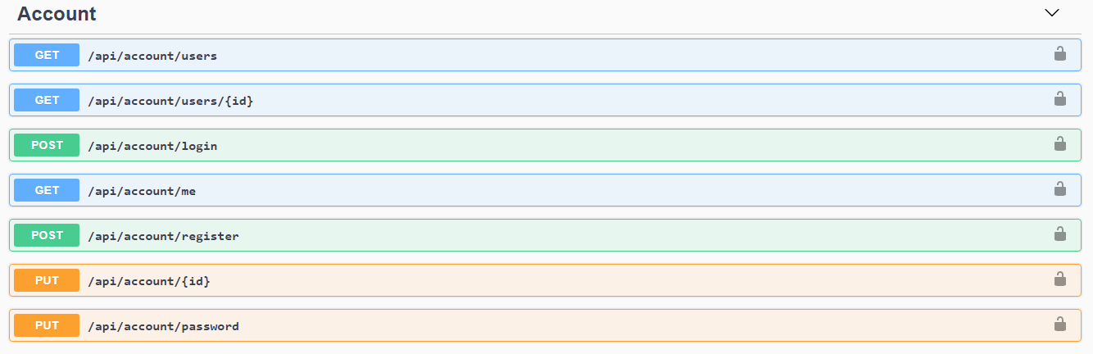
Image 8: Swagger UI
  - Why choose Swagger UI for API Testing?
- It is a dependency-free collection of HTML, Javascript, and CSS assets that dynamically generate beautiful documentation and sandbox from a Swagger-compliant API.
- Moreover Swagger UI easy to implement in .NET (We use .NET to build API) and it clear for React (We build app and website by React)
- Firebase
  - What is Firebase?
Firebase is a toolset to “build, improve, and grow your app”, and the tools it gives you cover a large portion of the services that developers would normally have to build themselves, but don’t really want to build, because they’d rather be focusing on the app experience itself. This includes things like analytics, authentication, databases, configuration, file storage, push messaging, and the list goes on. The services are hosted in the cloud and scale with little to no effort on the part of the developer.
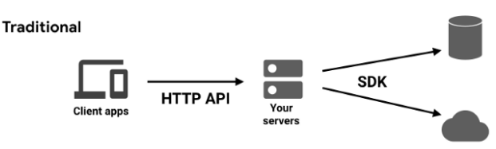
Image 9: Compare firebase with another platform
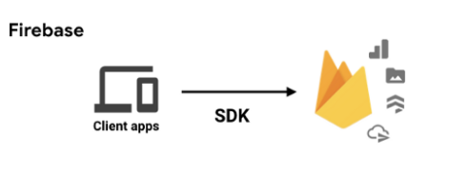
Image 10: Compare firebase with another platform

  - Firebase Cloud Messaging (FCM)
- In our application, we use Firebase Cloud Messaging for sending Push Notification to users. Whenever a fixer has a new order or a user's order status has been changed, our system will send a notification to FCM API, and then this notification will be sent back to them by FCM.
- FCM provides a reliable and battery-efficient connection between your server and devices that allows you to deliver and receive messages and notifications on iOS, Android, and the web at no cost.

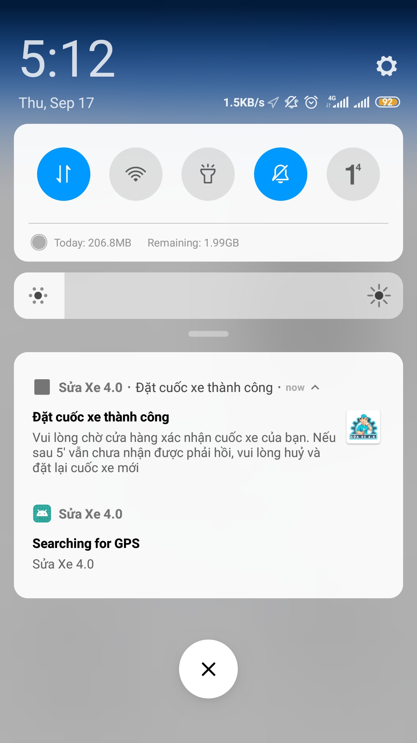
Image 11: Push notification sent by FCM
  - Firebase Phone Authentication
- In our application, we use Firebase Phone Authentication for sending OTP (One time password) to users via SMS when they register an account by phone number.
- Firebase Phone Authentication is a part of Firebase Authentication. It aims to make building secure authentication systems easy while improving the sign-in and onboarding experience for end-users. It provides an end-to-end identity solution, supporting email and password accounts, phone auth, and Google, Twitter, Facebook, and GitHub login, and more.

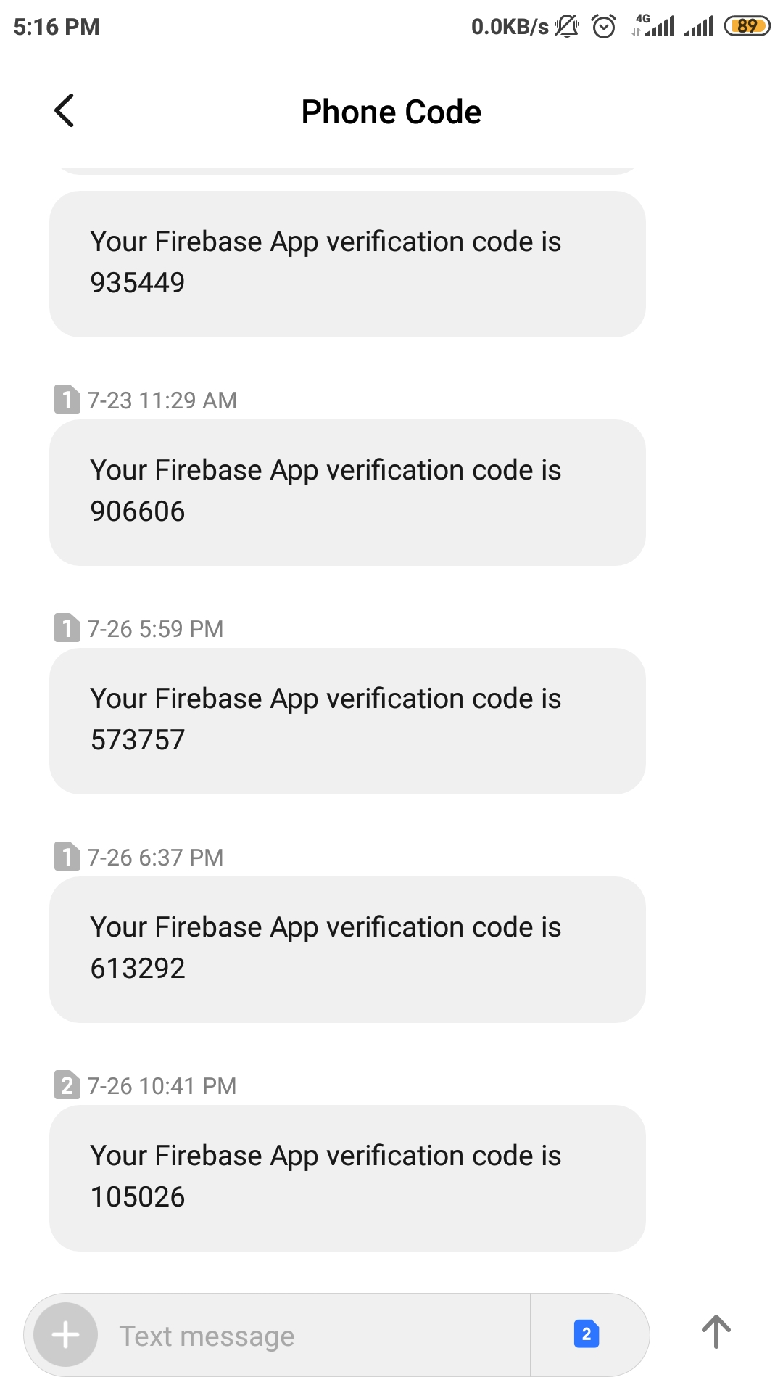
Image 12: SMS sent by Firebase Phone Authentication
- Figma (Design)
  - What is Figma?
Figma is a browser-based UI and UX design application, with excellent design, prototyping, and code-generation tools. We use Figma to design for our app.

Image 13: Logo Figma
  - How to use Figma?
Figma has two ways to use online and download application into the desktop
Online:
- Step 1: Access to link figma.com and you can login or sign up (if you don’t have account)
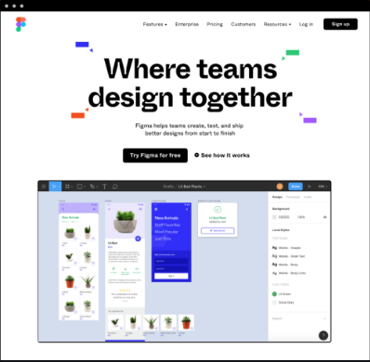
Image 14: Figma home page

- Step 2: Starting a project
  - After you have created an account at Figma, you will be presented with the following dashboard that presents you with all of your projects
  - Click the little + icon in the upper left corner of the top toolbar to create a new project.
  - This will present you with the following screen, where you will spend the majority of your time:
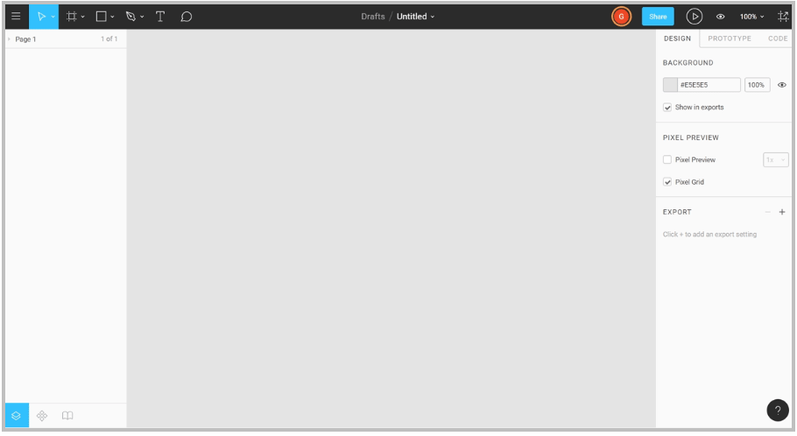
Image 1 : Starting a project by Figma
  - Download App
- Step 1: Access to link figma.com/downloads
- Step 2: The next step is to create the same project as above
  - The power of a Figma
- Figma has the most important feature of all — it’s free. The ease of access and install allow users to have all the tools they need to work as efficiently as possible
- Our mobile app live preview is a really nice touch. It helps us manage the quality and nuance of what we are designing. Real-time collaboration has changed the speed at which our team has been able to collaborate, create, and hand over designs to another member.
- GIT (Source code management)
  - What is Git?
Git is a free and open source distributed version control system designed to handle everything from small to very large projects with speed and efficiency.


Image 2 : Git logo

  - Rule use Git into project
- Rule 1: Create a Git repository for the project
  - After the team discusses the project (divide tasks), the leader in its the project “Vehicle-repair-4.0” in GitHub.
  - The member clone our repository to create a local copy on our computer and sync between the two locations.
  - git clone <link project>
- Rule 2: Understanding git branch
  - Master: The project has been done. It used only for release
  - Develop: Develop is the main branch where the source code of HEAD always reflects a state with the latest delivered development changes for the next release. We would call this the “integration branch”.
  - <name member><function>: Each member will receive a task from the leader and create a branch in Git base on the syntax.
- Rule 3: Use Pull Requests to merge code to Develop
  - The feature branches never push changes directly to the branch develop. Each member will open a new Pull Request to merge the feature branch code with the develop branch code.

CHAPTER 2. PROJECT INTRODUCTION AND SOLUTION
- Project Details
  - Data Requirements
    - Use Case Diagram
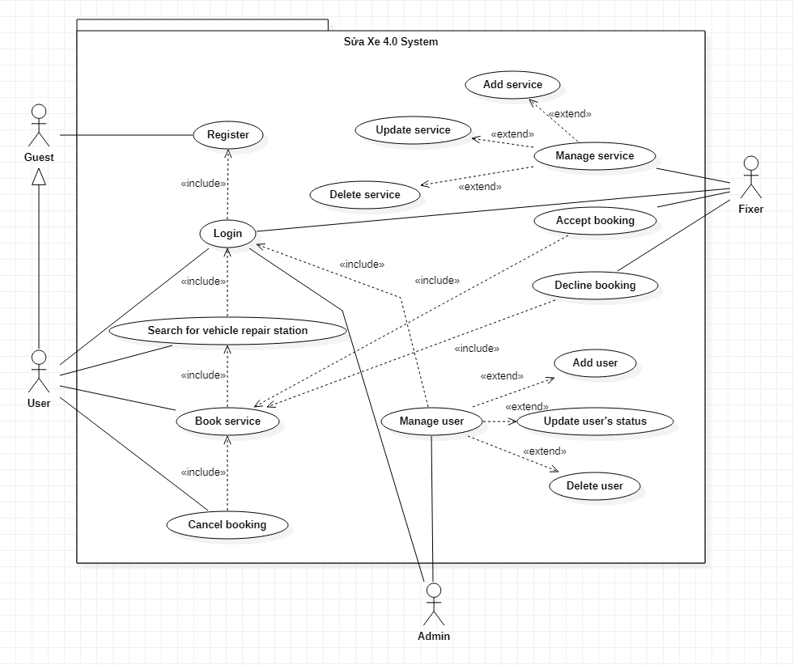
Image 3 : Use Case Diagram

    - Database
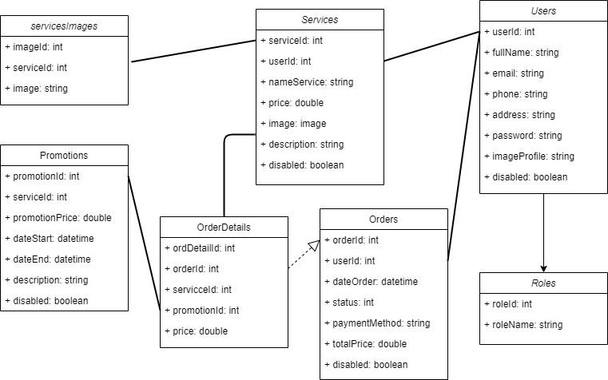
Image 4 : Database
  - Project Functions
      - App for user
- Registration/Login
  - Users will register accounts through the phone. Then the system sent the code by Firebase Cloud Message to confirm with the user.

Image 5 : Registration in User App

  - After user registration they will receive the code
Image 6 : The code send user after registration
  - After entering the code successfully, they will log in successfully
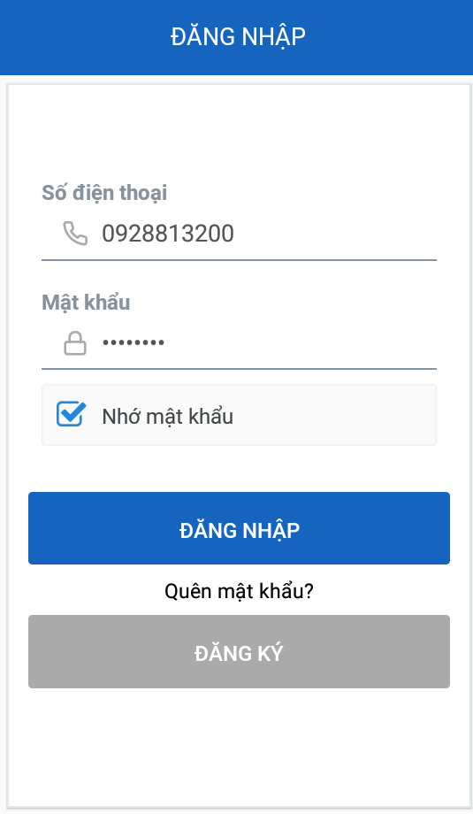
Image 7 : Login in User App

- Detect User Location
- Find the Nearest Vehicle Repair Station (Motorbike, Car)
- Directions to the Store
- See the Services Price Before Ordering
- Filter The Services They Need
- Booking History
- Push Notifications after booking
- View/Update Their Profile
- Feedback and Reviews on The Service

      - App for Fixer
- Registration/Login
- CRUD The Services
- Create a new service
- Update service
- Delete service
- View List of Order from User
- Accept/Cancel Order from User
- Statistics
- Success Rate
- Revenue of Store
- List Order
- Rating
- Order History
- View/Update Their Profile
      - Website for Admin
- General Statistics Store of System
- Show data about user, service, and order
- Solution
  - The architecture of the system
- To provide the good-quality find the vehicle repair station application, not only the mobile app interface matters, but also the "back-end" part. It is about the server application which receives user data, processes it, sending to certain services and apps. This back-end part actually makes communication between different elements of the mobile app system possible.
- The architecture can be explained as the 3 levels of the system work:
  - Servers
  - Applications on servers (back-end part)
  - Admin and mobile apps (front-end part)

CHAPTER 3. IMPLEMENTING AND TESTING

CONCLUSION

3.1. Archivement:
- Through this project, we have strengthened and learned some soft skills, as well as some technical knowledge, and we achieved some achievements like:
  - Had the opportunity to apply and improve the soft skills
  - Could manage source code, use Git and manage tasks in Trello proficiently
  - Knowing more about some new technologies: React Hooks, Swagger UI, React Native, React JS ...
- At the same time, we completed this project on time. Completed products as planned, including 1 web admin and 2 apps.
- Improve self-study ability and have responsibility for implementing projects
- We learned how to manage projects and manage our tasks appropriately, in addition, we learned how to solve problems, when a problem arises in the team, we always listen to each other to handle.
3.2. Project Improvement:
- In the future, we would like this application to be known and used by many people. It also helps people with vehicle damage conveniently repairing the vehicle, but it also helps owners to the more stable income.
- Our team's next development direction will be to reach vehicle repairmen so they can deliver their services to the app. We will survey the owner repair station monthly income, f rom there, we will take 10% of the monthly amount they earn to keep so they can keep using the app. And we will take 10% of stores with an income of over 1 million VND.
3.3. Advantage, disadvantage and lesson learnt
3.3.1. Advantage:
- From the beginning, our project had a clear purpose and content, so it didn't take too long to talk about the functions that would be in the app.
- Our team members are mostly developers, so coding apps, coding web, or learning a new technology is fast and efficient.
- Team members know quite well about using task management tools or source management. Therefore, work is always done on time and the source code is stored securely.
- The project is highly practical, so it is easy for people to imagine the requirements that are required for the application. The members are both developers and users to be able to change the application in positive directions.
3.3.2. Disadvantage:
- During this project, we also have to participate in internships and projects at the company, so the time is very limited and at the same time the equipment to make the project at school so we just use it every Saturday.
- The situation of Covid-19 disease, we were unable to return to the school yet, so the exchange of information and the exchange of ideas from afar was difficult (because each member of the group lives in different locations).

REFERENCE

[1]. https://vi.wikipedia.org
[2]. https://vov.vn/cong-nghe/diem-lai-cac-phien-ban-he-dieu-hanh-android-trong -10-nam-qua-798192.vov
[3]. https://www.howkteam.vn/course/khoa-hoc-lap-trinh-android-co-ban/cac-thanh-phan-giao-dien-ui-co-ban-72
[4]. http://giasutinhoc.vn/lap-trinh-android-co-ban/xu-ly-su-kien-trong-android -bai-3/
[5]. https://viblo.asia/p/su-dung-intent-trong-ung-dung-android-3Q75wyBGZWb
[6]. https://www.youtube.com/user/khoazend/videos
[7]. https://dev.mysql.com/doc/
[8]. http://www.sqlservertutorial.net/
[9]. https://docs.microsoft.com/en-us/dotnet/
[10]. https://code.visualstudio.com/docs/languages/csharp
[11]. https://www.w3schools.com/
[12]. ….

SUPERVISOR COMMENTS

…………………………………………………………………………………
…………………………………………………………………………………
…………………………………………………………………………………
…………………………………………………………………………………
…………………………………………………………………………………
…………………………………………………………………………………
…………………………………………………………………………………
…………………………………………………………………………………
…………………………………………………………………………………
…………………………………………………………………………………
…………………………………………………………………………………
…………………………………………………………………………………
…………………………………………………………………………………
…………………………………………………………………………………
…………………………………………………………………………………
…………………………………………………………………………………
…………………………………………………………………………………
…………………………………………………………………………………
…………………………………………………………………………………
…………………………………………………………………………………
…………………………………………………………………………………
…………………………………………………………………………………

